

**LINUX LAB FILE**

**Name : Ashutosh Shrivastava**

**Sap id:** **590027859**

**Batch :78**

**Course :B.tech computer science**

**EXPERIMENT :1**

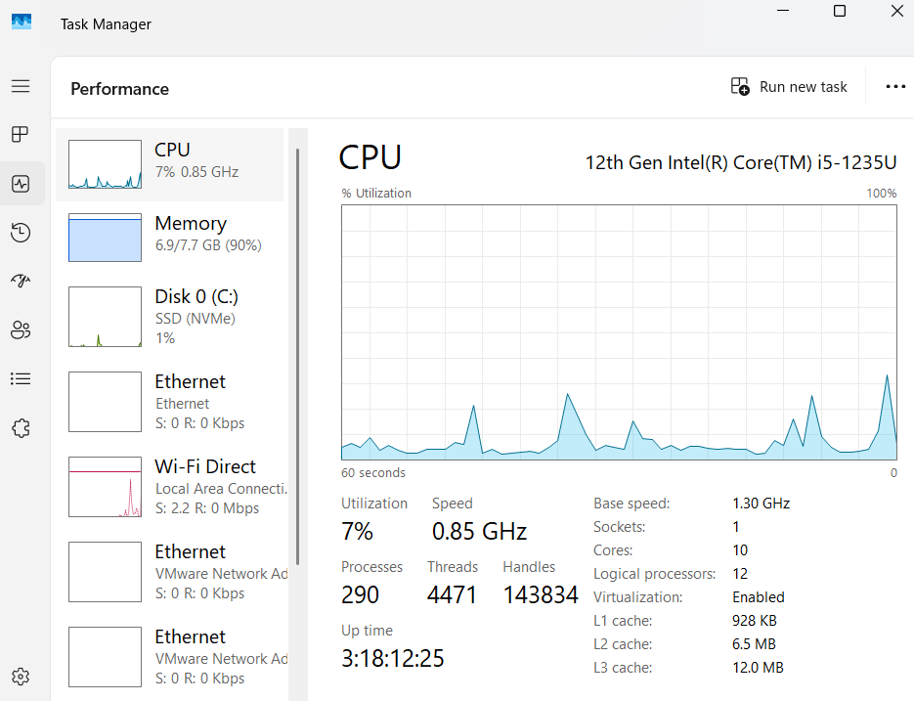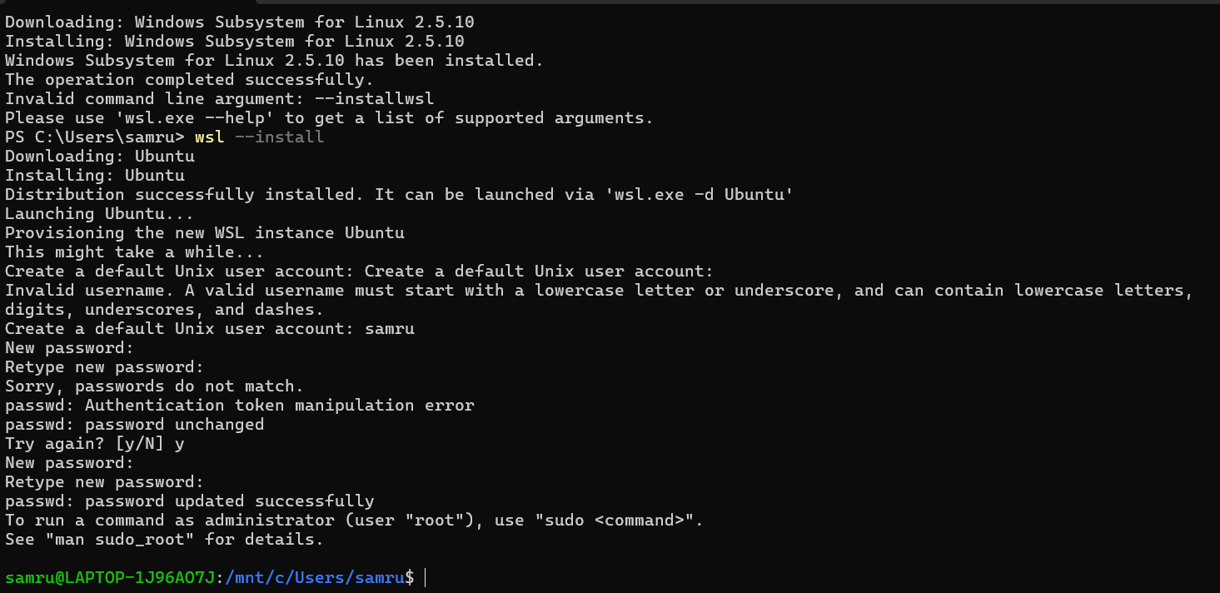

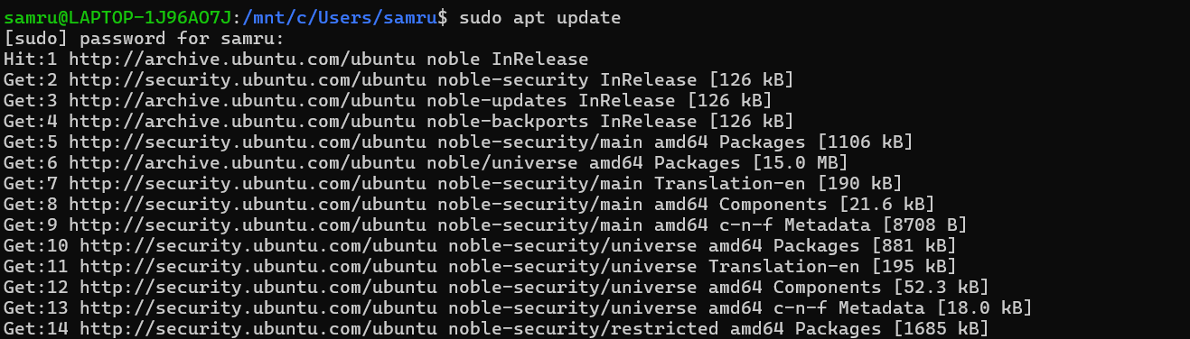

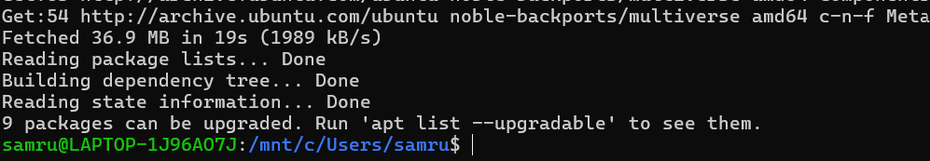

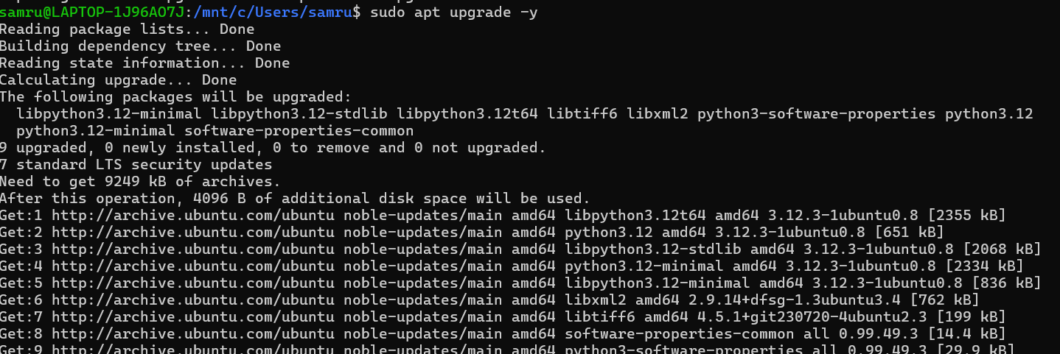

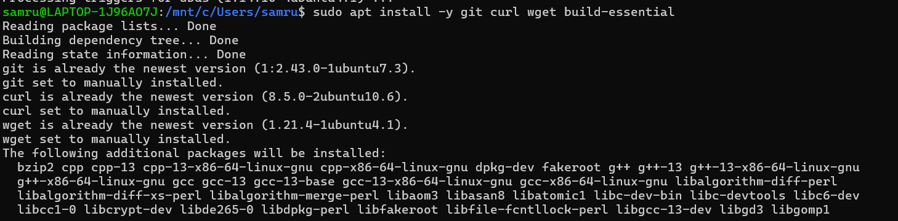

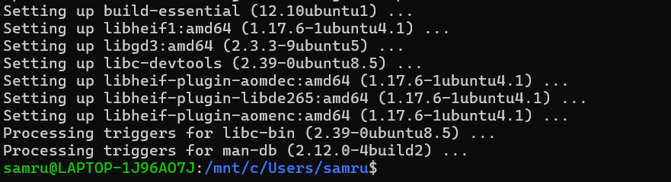

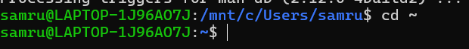

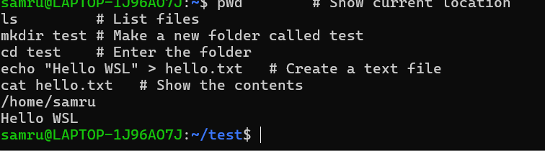

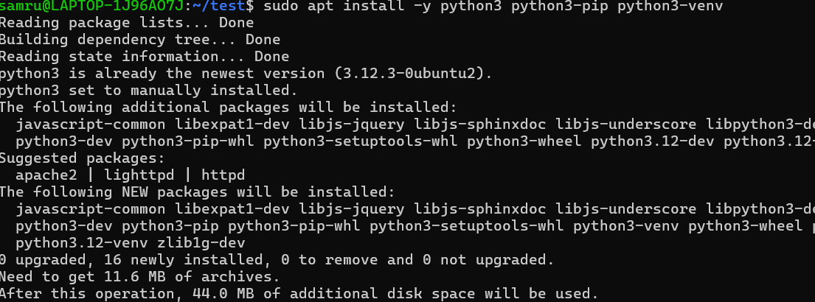

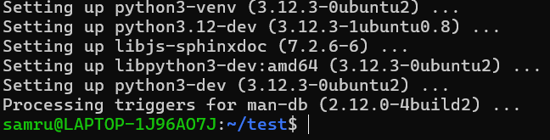

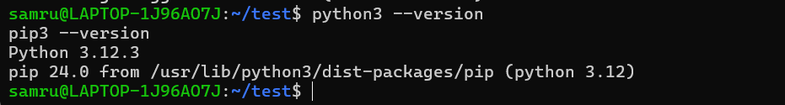



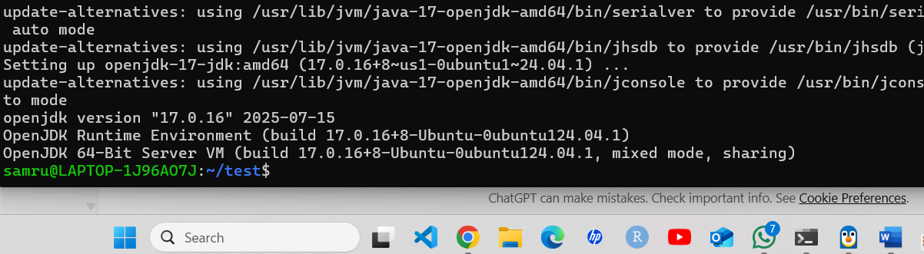

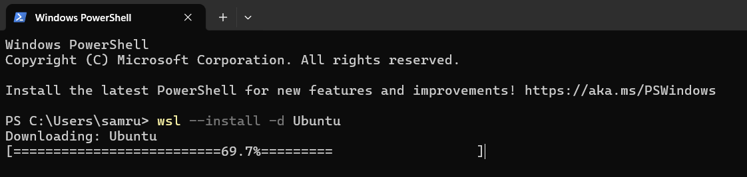

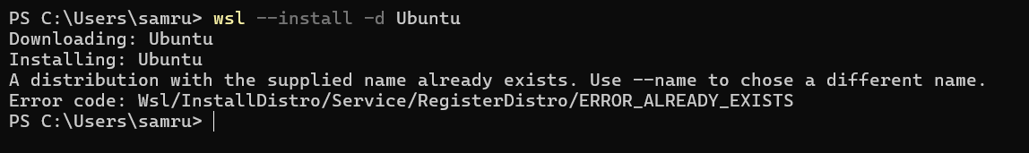

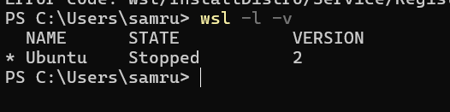

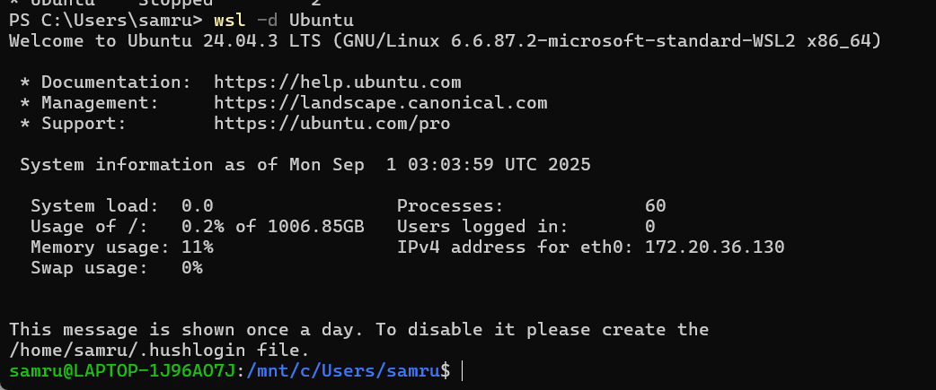

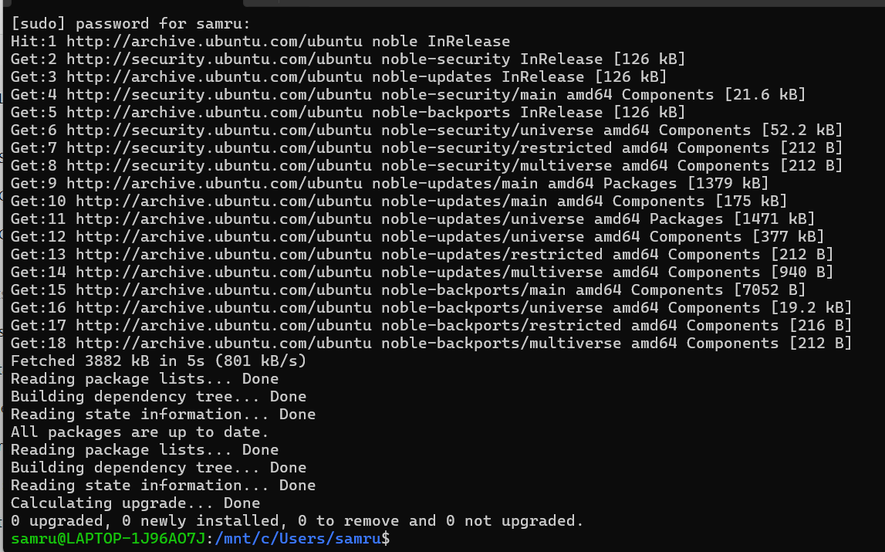

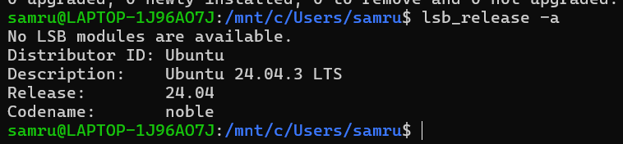

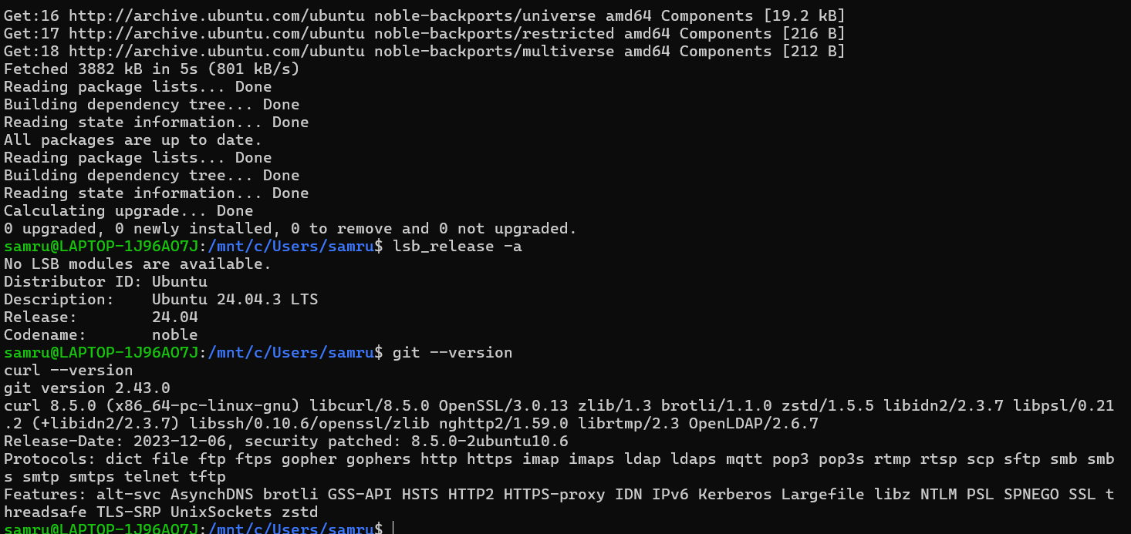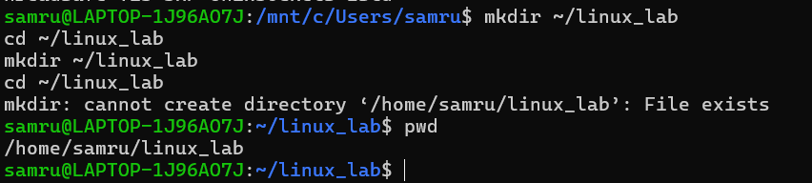

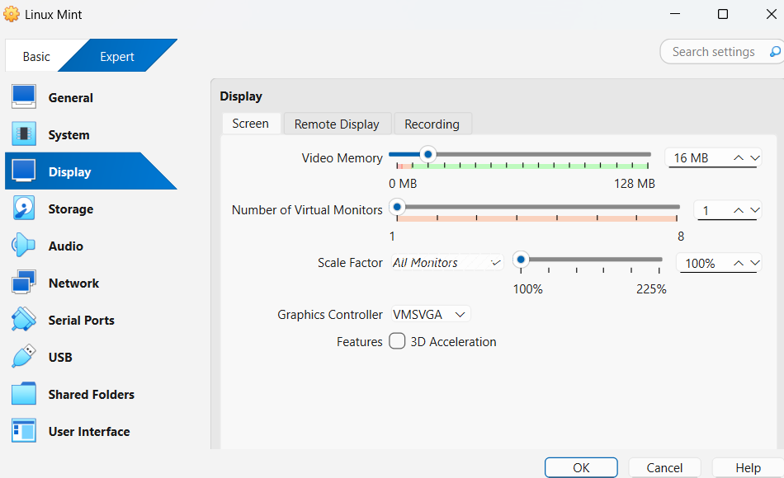

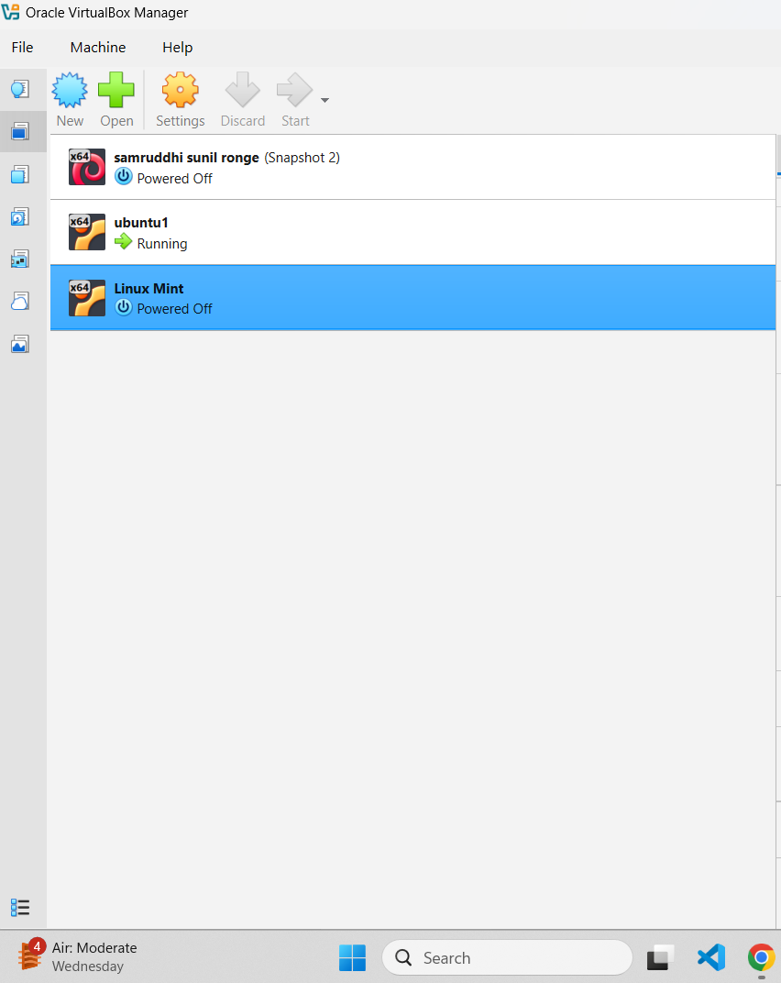

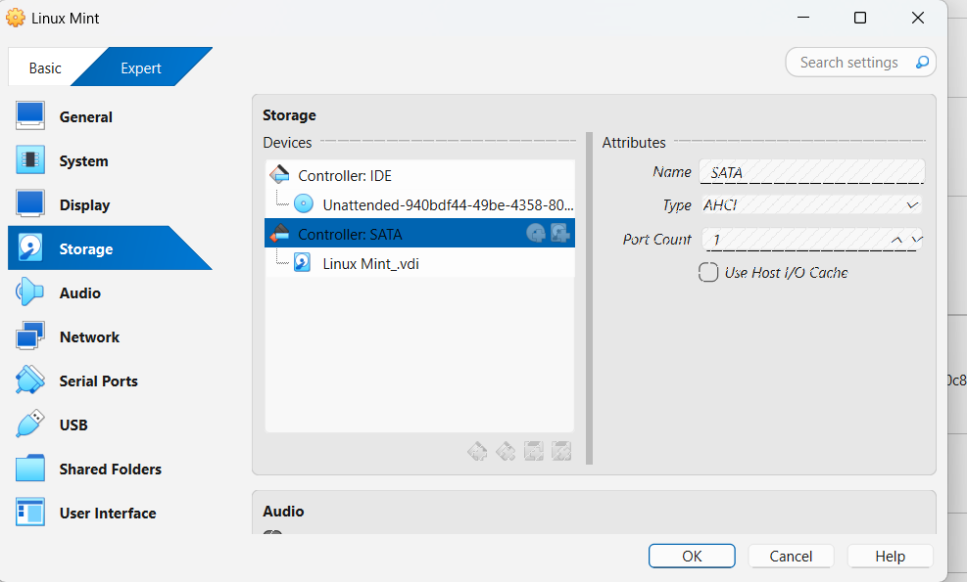

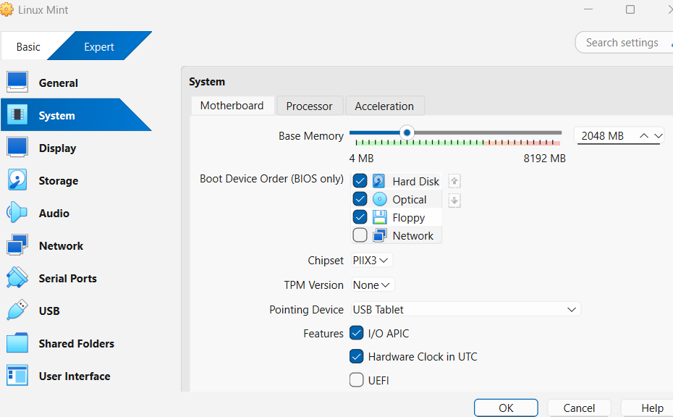

**EXPERIMENT :2**

**EXPERIEMENT 3**

**Basic File Operations**

**Lab section 2:**

**EXPERIMENT 4**

**EXPERIMENT 5:**

**EXPERIMENT 6:**

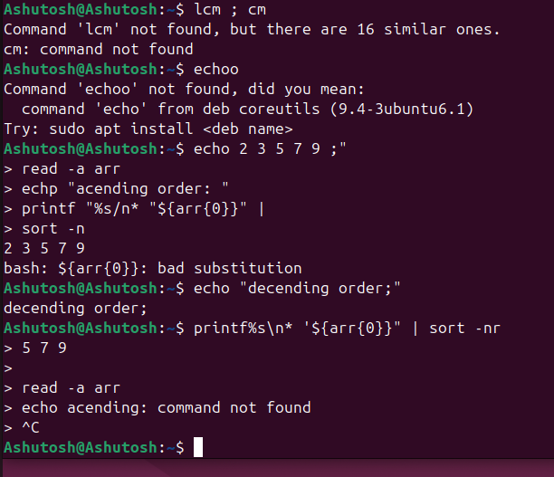

**Experiment 7:**

**Experiment 8:**

**ASSIGNMENT 1:**

**EXPERIMENT 9: Shell programming**

Theory:

1.System performance monitoring system performance is tracked using CPU. Memory.disk.and network usage.

. top:LIVE CPU & MEMORY USAGE PER PROCESS.

. htop:Improved version of top (interactive).

. free -h:Memory usage in human – readable form

. df -h:Disk space usage.

. isotat: Input/output statistics.

. uptime: system load average (1,5,15 minutes).

2.System Security and User Management Linux is multi-User. ti-user. Security involves controlling file permissions, users, and groups.

* whoami: Displays current user.
* id: User & group info.
* adduser <name>: Add a new user.
* passwd <name>: Set/change password.
* groups: Display user’s groups.
* chmod: Change permissions (read, write, execute).
* chown: Change ownership.

Lab Execution (Commands to Run):

Part A: Performance Monitoring

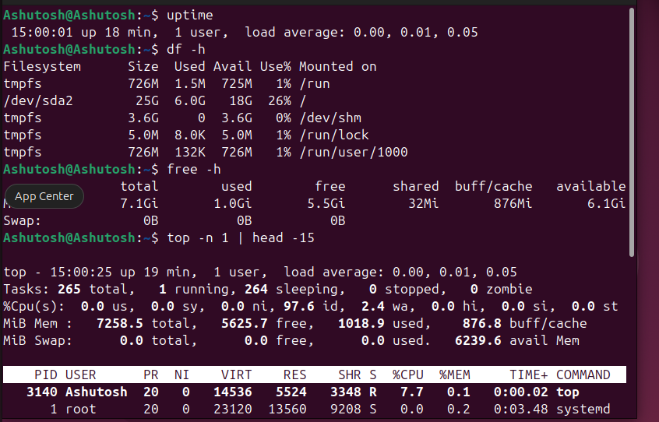

**EXPERIMENT 10: Shell Programming - Complete Guide**

Theory:

1. Modular and Reusable Code Modular programming means breaking down a program into smaller, independent, and reusable components. In shell scripting, this is achieved through Functions and Sourcing Scripts.

* Functions: Named blocks of code that can be called multiple times to improve readability and reduce duplication.
* Sourcing Scripts: Using . script.sh or source script.sh to include external scripts. This makes functions and variables from the sourced file available in the current script without creating a subshell.

2. Script Optimization Techniques

* Avoid unnecessary subshells: Each $(command) creates a new process.
* Use built-in string operations: Bash built-ins are faster than external commands like sed or awk.
* Minimize loops: Use shell expansions where possible.

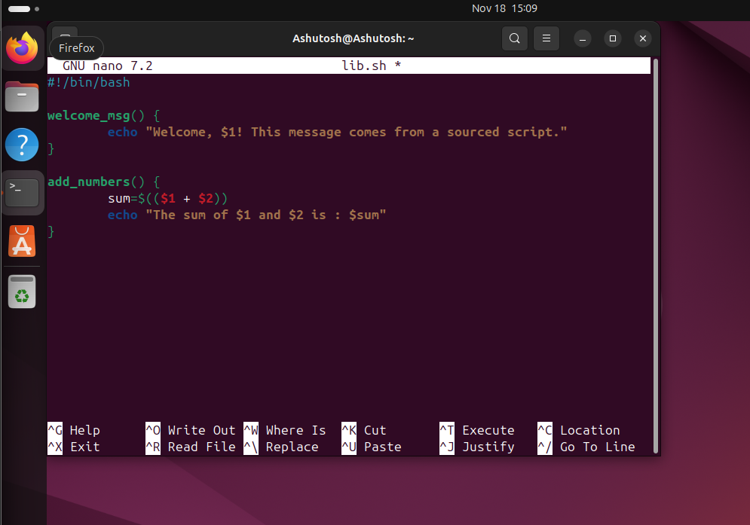

**EXPERIMENT 11: Interacting with Users: Interactive Shell Scripts**

**Theory:**

1. Interactive Shell Scripts Interactive scripts engage users in two-way communication, making programs more user-friendly. Key components include the read command and the select command.

A. User Input with read

* Reads input from standard input (keyboard).
* Stores input in variables.
* Common Flags:
  + -p: Prompt with input.
  + -s: Silent input (for passwords).
  + -t: Timeout (in seconds).
  + -n: Read N characters.

B. Menu Systems with select

* Creates interactive menus automatically.
* Provides numbered options for user selection.
* Has a built-in loop for handling user choices.

**EXPERIMENT 12: Building a Rule-Based Expert System - Complete Guide**

Theory:

1. Process Automation and Job Scheduling

* cron: Time-based job scheduler for repetitive tasks.
  + Syntax: minute hour day month day_of_week command
  + Example: 0 9 * * * /home/user/backup.sh (Executes daily at 9 AM).
    - at: One-time job scheduling.
  + Example: echo "backup.sh" | at 2:00 AM tomorrow.

2. Services and Daemons System service management is handled using systemctl.

* systemctl start service: Start a service.
* systemctl stop service: Stop a service.
* systemctl status service: Check service status.
* systemctl enable service: Enable auto-start at boot.

